**Assignment 1**

**Name : Adwait Purao**

**UID : 2021300101**

**Class : T.E. COMPS B**

**Disruptive Innovation: Airbnb**



### **Introduction to Airbnb**

Airbnb, founded in 2008 in San Francisco, emerged as a pioneering platform in the sharing economy, fundamentally altering the landscape of the hospitality industry. It introduced a novel concept that allowed individuals to rent out their spare rooms or entire homes to travelers. This model not only provided a new source of income for hosts but also offered travelers more diverse and often more affordable accommodation options compared to traditional hotels.

### **Key Innovations**

* **Platform Model:** Airbnb developed a user-friendly online platform that seamlessly connects hosts with guests. The platform includes features such as user profiles, reviews, and secure payment systems, fostering trust and safety among users.
* **Diverse Listings:** Unlike traditional accommodations, Airbnb offers a wide range of lodging types, from single rooms to castles, providing unique experiences that cater to diverse traveler preferences.
* **Dynamic Pricing:** Airbnb introduced a dynamic pricing model that adjusts rental prices based on various factors such as demand, location, and time of year, optimizing earnings for hosts and affordability for guests.

### **Major Breakthroughs**

* **Global Expansion:** Rapidly expanding its presence worldwide, Airbnb transformed from a startup to a global marketplace, offering listings in more than 100,000 cities across the globe.
* **Technological Integration:** The company has consistently leveraged technology, including the development of sophisticated algorithms for pricing suggestions, search optimization, and personalized recommendations.
* **Community Building:** Airbnb has successfully cultivated a strong community of hosts and travelers, emphasizing shared experiences and cultural exchange, which has been central to its brand identity.

### **Marketing Strategy**

Airbnb's marketing strategy has been pivotal in its disruptive impact, characterized by:

* **Word-of-Mouth:** Leveraging positive user experiences to fuel organic growth, Airbnb benefitted significantly from word-of-mouth referrals.
* **Social Media and Content Marketing:** By encouraging users to share their travel experiences, Airbnb effectively utilized social media and content marketing to engage a broader audience.
* **Innovative Campaigns:** Campaigns like "Live There" tapped into the desire of travelers to experience destinations "like a local," differentiating Airbnb from traditional hotel stays.

### **Conclusion**

Airbnb stands as a quintessential example of disruptive innovation in the hospitality industry. By leveraging technology to create a new business model, it has significantly broadened the accommodation market, providing more flexibility and personalized options for travelers. Its success disrupted traditional hotel businesses, prompting them to reconsider their service offerings and pricing models. Furthermore, Airbnb's emphasis on community and experience over mere transactions has not only fueled its growth but also reshaped consumer expectations in travel. As it continues to evolve, Airbnb's journey underscores the transformative power of disruptive innovation in reshaping industries and consumer behavior.

**Incremental Innovation : Google Maps**

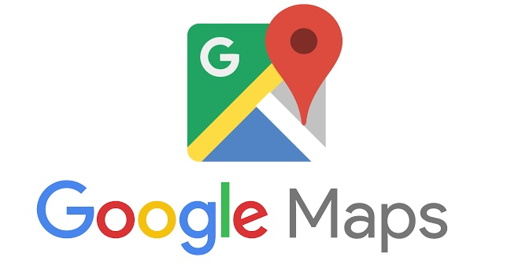

### **Introduction to Google Maps**

Launched in 2005, Google Maps began as a simple web-based mapping service that aimed to provide accurate, easy-to-use maps and directions to users worldwide. Over the years, it has evolved significantly, incorporating various features that have made it an indispensable tool for millions of people for navigation, local exploration, and planning travels.

### **Key Innovations**

* **Street View:** Introduced in 2007, Street View was a groundbreaking feature that provided panoramic, street-level imagery, allowing users to virtually explore cities and neighborhoods as if they were there in person.
* **Real-Time Traffic Updates:** By analyzing location data from smartphones and historical traffic patterns, Google Maps can provide users with real-time traffic conditions, suggesting the fastest routes to their destinations.
* **Integration of Public Transit:** Google Maps integrated public transit options, including buses, trains, and subways, offering schedules and route recommendations, simplifying urban navigation for daily commuters and travelers alike.

### **Major Breakthroughs**

* **Widespread Mobile Adoption:** The integration of Google Maps into Android and its availability on iOS devices have made it a staple mobile application, essential for real-time navigation and location-based searches.
* **Local Business Integration:** By allowing local businesses to list on Google Maps, complete with reviews, ratings, and operational information, it has become a vital tool for local discovery and business visibility.
* **API for Developers:** The provision of Google Maps APIs to developers enabled the integration of maps and location-based services into third-party apps and websites, further extending its utility and ubiquity.

### **Marketing Strategy**

Google Maps’ marketing strategy has revolved around its utility, accuracy, and integration capabilities:

* **Utility-Based Promotion:** Google Maps is often marketed through its utility, showcasing its ability to simplify navigation, exploration, and planning for users.
* **Collaborations and Integrations:** Collaborating with cities for public transit data, businesses for listings, and developers through APIs has not only enhanced its features but also served as a marketing tool, embedding Google Maps into various aspects of everyday life.
* **Content and Educational Campaigns:** Google has utilized content marketing, highlighting features, tips, and tricks through various channels, educating users on getting the most out of Google Maps.

### **Conclusion**

Google Maps exemplifies incremental innovation through its continuous evolution and addition of features that enhance its core utility. It has transformed from a simple mapping service into a comprehensive tool for navigation, exploration, and local discovery. Each incremental innovation, from Street View to real-time traffic updates, has solidified its position as a leader in digital mapping services. By focusing on user needs, integrating with various services, and consistently improving its offerings, Google Maps has not only maintained its relevance but also set the standard for what users expect from mapping and navigation technologies. Through strategic marketing and a commitment to enhancing user experience, Google Maps continues to expand its impact, demonstrating the power of incremental innovation in sustaining long-term growth and success.